AI-ENABLED WATER WELL PREDICTOR

Dr. Susheelamma KH^{*1}, Annasagaram Lasyapriya^{*2}, Spoorthi S^{*3}
^{*1}Assistant Professor, Department Of Information Science And Engineering, S J C Institute Of Technology Chickaballapur, India.
^{*2,3}Under Graduate Student, Department Of Information Science And Engineering, S J C Institute Of Technology Chickaballapur, India.
DOI : https://www.doi.org/10.56726/IRJMETS55573

ABSTRACT
Developing accurate soft computing methods for groundwater level (GWL) forecasting is essential for enhancing the planning and management of water resources. Over the past two decades, significant progress has been made in GWL prediction using machine learning (ML) models. The article do not cover several aspects of GWL simulations using ML, which are significant for scientists and practitioners working in hydrology and water resource management. In our project we aim to provide a clear understanding of the ML models implemented for GWL modeling and the milestones achieved in this domain.
Keywords: Planning, Machine Learning.

INTRODUCTION
Groundwater has been the prime source of fresh water sustaining life and livelihood in India. Share of groundwater in irrigation has increased from 61% in 2007-08 to 64% in 2016-17 as per the data of Directorate of Economics & Statistics Ministry of Agriculture & Farmers Welfare. Dependence on ground water is increasing day by day as groundwater accounts for most of the increase in net irrigated area in the country. This hasn’t come without a price.
As per the latest assessment of Dynamic Ground Water Resources (2022), out of the total 7084 assessment units (Blocks/ Taluks/ Mandals/ Districts/Valleys), 1006 (14%) have been categorized as ‘Over-exploited’, 260 (4%) as ‘Critical’, 885 (12%) as ‘Semi-critical’. Alongside over-exploitation there are also areas where existing groundwater resources have not been tapped properly. Further, there are well documented issues of ground water contamination also.
Climate change is likely to bring in more challenges in terms of decreasing availability, increasing demand for irrigation (because of increase in atmospheric temperature) and increase in coastal salinity (because of rise in sea level). Govt. of India, The State Governments and many other agencies are doing their best to augment and manage ground water resources. However, understanding of the aquifers is the first prerequisite to prepare effective management interventions.
The report of the Working Group (constituted by the erstwhile Planning Commission) for the XII plan on ‘Sustainable Ground Water Management’ highlighted the need for comprehensive mapping of India’s aquifers, on priority, that would form the cornerstone of developing any groundwater management programme. In this backdrop, Central Ground Water Board (CGWB), under the Ground Water Management and Regulation Plan Scheme (XII plan) initiated the National Aquifer Mapping and Management (NAQUIM) programme in the year 2012, which is one of the largest endeavours of its kind in the World.

METHODOLOGY
- Data Collection: Gather comprehensive data, including groundwater level observations, statistics, maps, and any available field experiment results (e.g., pumping tests, geophysics, soil and land use maps, topography, and slope data).
- GMS Model Implementation: Utilize the Groundwater Modeling System (GMS) to simulate groundwater level fluctuations in the Sonqor plain. Incorporate available statistics, information, and maps into the model.
- Calibration and Validation of GMS Model: Calibrate the GMS model using historical data to ensure it accurately represents observed groundwater levels. Validate the model using a separate dataset to confirm its reliability for predictive purposes.
- Artificial Intelligence Integration: Integrate artificial intelligence (AI) models, including GA-ANN, ICAANN, ELM, and ORELM, into the project framework.
- Comparison of AI Models: Compare the performance of the GA-ANN, ICA-ANN, ELM, and ORELM models by assessing their correlation with observed data and examining the distribution of scatter points around the 45-degree line.
- ORELM Model Optimization: Optimize the Online Sequential Extreme Learning Machine (ORELM) model parameters to enhance its accuracy in simulating groundwater level fluctuations.

MODELING AND ANALYSIS
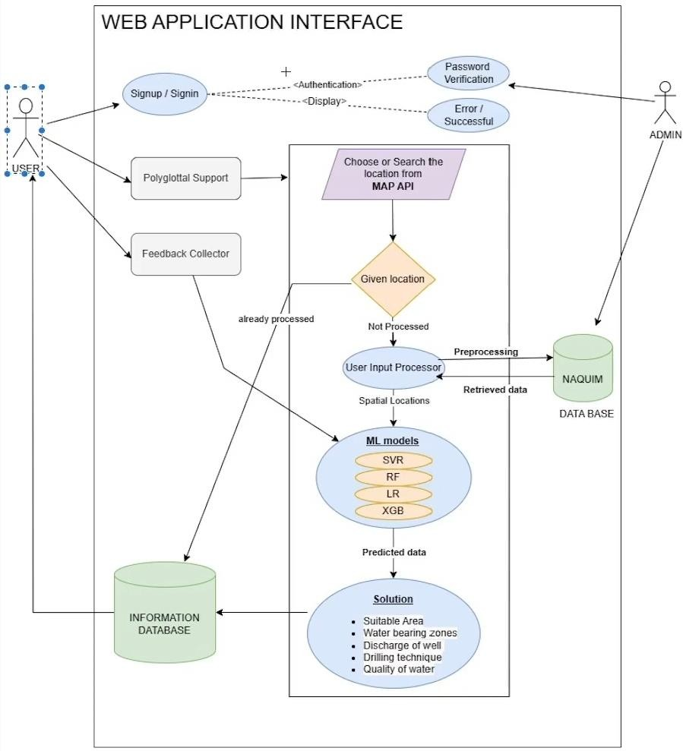
Figure 1: Block Diagram
An AI-enabled water well predictor using machine learning (ML) works by analyzing various data points related to water wells and their surroundings to predict the likelihood of finding water or the quality of water in a particular location. The effectiveness of an AI-enabled water well predictor depends on the quality and quantity of data available for training, the choice of appropriate features and algorithms, and the thoroughness of model validation and testing.

RESULTS AND DISCUSSION
Table 1: Test Cases for user login
Test Cases No. | Test  Name | Test Description | Input | Expected  Output | Actual Output | Test Results
01 | User  Login  Success | user enters correct username and password to login | Username: admin,  Password: abcds | Successful login message | Successful login message | Success
02 | User  Login  Failure | user enters  incorrect user name  and password to login | Username: incorrect,  Password: admin | Error message:  "Invalid username or password" | Error message:  "Invalid username or password" | Success
Table 2: Test cases for load & process dataset
Test Cases No. | Test Name | Test Description | Input | Expected  Output | Actual Output | Test Results
03 | Load Dataset | Test uploading and  loading a dataset | Sample  dataset file | Success message | Success message | Success
04 | Process  Dataset | Test dataset preprocessing  (e.g., handling missing values, normalization) | Sample dataset | Processed dataset | Processed dataset | Success
Table 3: Test cases for visualize processed dataset
Test Cases No. | Test Name | Test Description | Input | Expected  Output | Actual Output | Test Results
05 | Visualize  Dataset | Test visualization of  dataset  through graphs | Processed dataset | Graph showing  distribution of  groundwater  levels | Graph showing  distribution of  groundwater  levels | Success
Table 4: Test cases for run ml algorithms
Test Cases No. | Test Name | Test Description | Input | Expected  Output | Actual Output | Test Results
06 | Run SVM Algorithm | Test SVM algorithm  training and prediction | Training dataset, Testing dataset | Prediction accuracy | Prediction accuracy | Success
07 | Run Random  Forest  Algorithm | Test Random  Forest algorithm  training and prediction | Training dataset, Testing dataset | Prediction accuracy | Prediction accuracy | Success
Table 5: Test cases for water detection
Test Cases No. | Test Name | Test Description | Input | Expected  Output | Actual Output | Test Results
08 | Detect  Water | Test groundwater  level  prediction using  trained model | Test dataset | Predicted labels | Predicted labels | Success
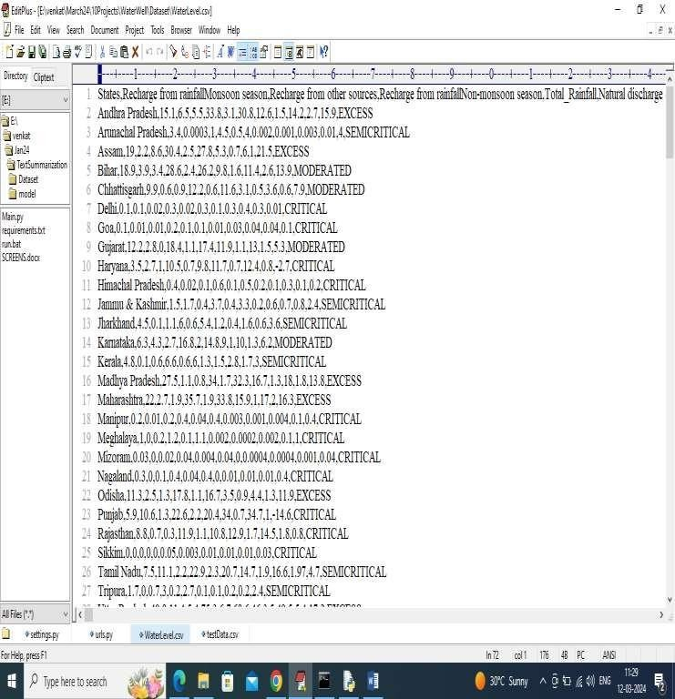
Figure 2: Dataset Screens
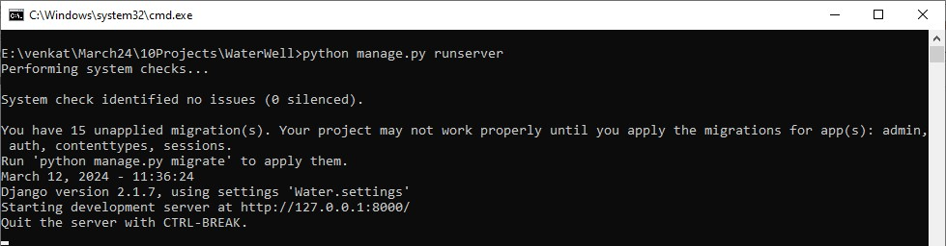
Figure 3: Python Server Screen
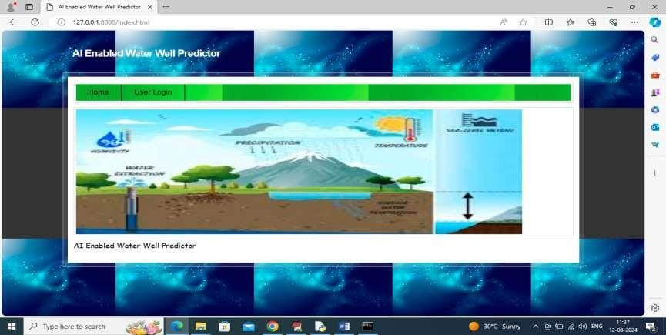
Figure 4: Home Screen
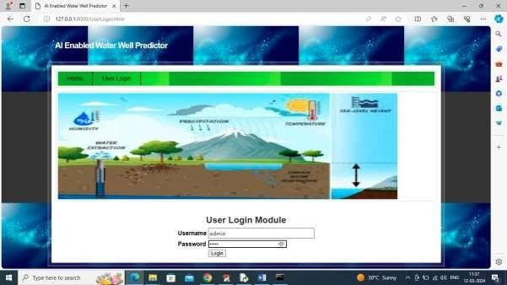
Figure 5: Login page
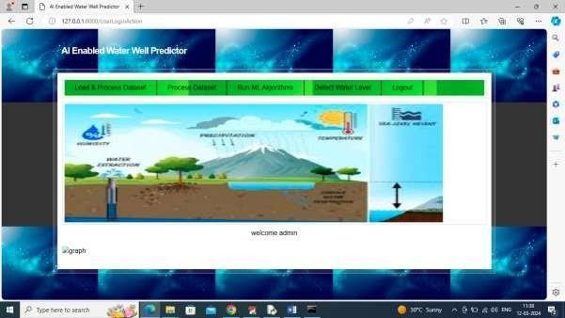
Figure 6: Load & Process Dataset
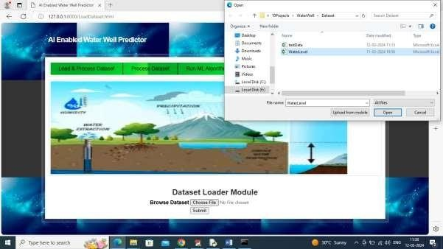
Figure 7: Water level Dataset File
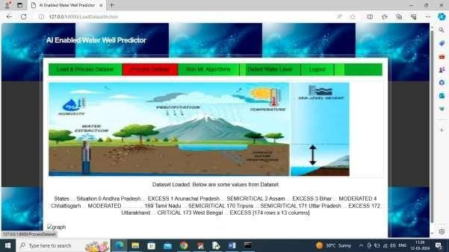
Figure 8: Processed Dataset
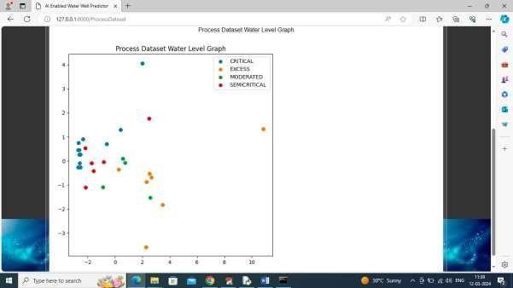
Figure 9: Graph

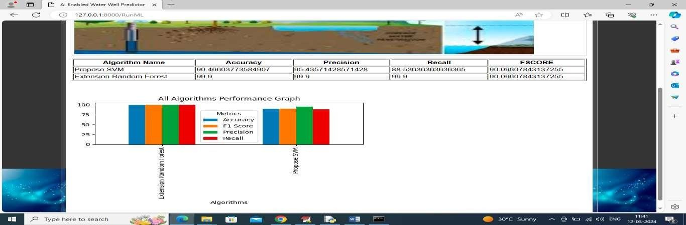
Figure 10: Algorithm Performance in Tabular & Graph Formate
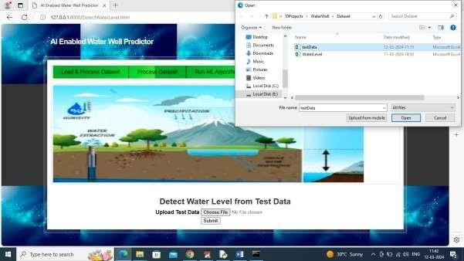
Figure 11: Test Data
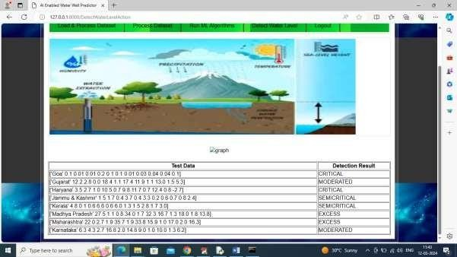
Figure 12: Test Data Values

CONCLUSION
In conclusion, Modeling and prediction of water level are very important for the protection of the environment. Developing a model by using advanced artificial intelligence algorithms can be used to measure the future water quality.
An AI-enabled water well predictor using machine learning offers a powerful solution for assessing water availability and quality in specific locations. By leveraging diverse data sources and advanced algorithms, it can provide valuable insights to aid in decision-making related to water resource management, agriculture, and infrastructure development. However, the effectiveness of such a system depends on the quality of data, thorough model training, and ongoing validation to ensure accurate predictions. Overall, it represents a promising tool for addressing water-related challenges and promoting sustainable use of resources.

REFERENCES
- Lo, W.C.; Borja, R.I.; Deng. J.H.; Lee, J.W. Analytical Solution of Soil Deformation and Fluid Pressure
Change for a two-layer System with an Upper Unsaturated Soil and a Lower Saturated Soil under External Loading. J. Hydrol. 2020, 588, 124997. [Cross Ref]
- Yu, P.-S.; Yang, T.-C.; Wu, C.-K. Impact of climate change on water resources in southern Taiwan. J. Hydrol. 2002, 260, 161-175. [CrossRef]
- Chen, C.-H.; Wang, C.-H.; Hsu, Y.-J.; Yu, S.-B.; Kuo, L-C. Correlation between groundwater level and altitude variations in land subsidence area of the Choshuichi Alluvial Fan, Taiwan.
- Eng. Geol. 2010, 115, 122-131. [Cross Ref] Tran, D.-H.; Wang, S.-J. Land subsidence due to groundwater extraction and tectonic activity in Pingtung Plain, Taiwan. Proc. IAHS 2020, 382, 361- 365. [CrossRef]
- WRA (Water Resources Agency). Report of the Monitoring, Investigating and Analyzing of Land Subsidence in Taiwan (1/4); Ministry of Economic Affairs, Executive Yuan: Taipei, Taiwan, 2001.
- A. Kahlown, M. A. Tahir, and H. Rasheed, National Water Quality Monitoring Programme, Fifth Monitoring Report (2005–2006), Pakistan Council of Research in Water Resources Islamabad, Islamabad, Pakistan, 2007
- Steve Williams ,T Rashid, “Clean water for a healthy world,” Tech. Rep., Development, 2010
- Payne, and R. Emanuel, “Water Quality & Monitoring”, University of Arizona Repository, 2000
- Taskaya-Temizel and M. C. Casey, “A comparative study of autoregressive neural network hybrids”, Neural Networks, 2005.
- Zeilhofer, L. V. A. C. Zeilhofer, E. L. Hardoim, Z. M.Lima, and C.S.Oliveira, “GIS applications for mapping and spatial modeling of urban-use water quality: a case study in District of Cuiabá, Mato Grosso, Brazil,” Cadernos de Saúde Pública, vol. 23, no. 4, pp. 875–884, 2007.

---

### *1. Problem the Research Paper Addresses*

The paper focuses on the *challenge of predicting groundwater levels* in aquifers, which is critical because:

* Groundwater is the main freshwater source for agriculture, domestic use, and industry.
* Traditional statistical or numerical models are limited in accuracy under complex conditions (climate variability, pumping, recharge, etc.).
* Missing or incomplete data, as well as high non-linearity in groundwater systems, make prediction difficult.

---

### *2. Solution the Paper Proposes*

The authors propose a *hybrid deep learning model* using:

* *Multi-Layer Perceptron (MLP)* – a neural network that learns nonlinear patterns.
* *Adam optimizer* – improves training efficiency and accuracy by adaptively adjusting learning rates.

Key outcomes:

* Inputs: precipitation, temperature, weighted groundwater level averages.
* Output: predicted groundwater levels in the *Najafabad aquifer* (Iran).
* Performance: high accuracy with *R² = 0.9458* and *RMSE ≈ 0.73*.
* Conclusion: AI-based deep learning methods (like MLP + Adam) are more reliable than traditional approaches for *groundwater level forecasting*.

---

### *3. Topics They Did Not Focus On (Gaps / Limitations)*

While the paper makes good progress, there are *several areas left unexplored*, which your project can address:

1. *Suitability for Water Well Construction*

* The paper predicts *water levels*, but not whether a location is suitable for drilling a new well.
* No consideration of lithology, aquifer maps, or drilling feasibility.

2. *Depth of Water-Bearing Zones*

* Their model gives the groundwater level, but doesn’t identify *specific aquifer depths or multiple water-bearing layers*.

3. *Well Discharge (Yield)*

* They don’t predict how much water a well might yield (safe pumping rate/discharge).

4. *Water Quality*

* No discussion of groundwater quality (contamination, salinity, hardness, suitability for drinking/irrigation).

5. *Best Drilling Technique*

* The study does not recommend drilling methods (rotary vs percussion, etc.) depending on soil/rock type.

6. *User-Facing Interface*

* Their approach is purely modeling-focused, not presented as a *decision-support system* for common users.
* No interactive GIS-based system or user-friendly dashboard is proposed.

7. *Integration of NAQUIM / CGWB Data*

* They used local meteorological + aquifer data (Iran case study), but not comprehensive datasets like *lithology, geophysical logs, maps* (which your project explicitly aims to leverage).

---

### *4. Where You Can Extend (Your Research Opportunities)*

Your project can go beyond their work by:

* Expanding from *just prediction of water levels* → to *decision-making for water well construction*.
* Integrating *NAQUIM/CGWB datasets*: lithology, geophysical logs, aquifer mapping, quality, etc.
* Using *AI predictors* not only for water levels, but also:

* Suitability analysis for drilling
* Depth of water-bearing zones
* Expected discharge/yield
* Quality assessment
* Drilling recommendations
* Creating a *GIS-based interactive web platform* for non-experts (farmers, local decision makers).
* Linking with *SDG 6 (Clean Water & Sanitation)* by addressing access, quality, and sustainability.

---

✅ In short:

* *Their paper’s contribution*: Accurate groundwater level prediction using MLP + Adam.
* *Their limitations*: No focus on drilling suitability, discharge, quality, user-interface, or national-scale datasets.
* *Your opportunity: Develop a **decision-support system* that combines their predictive AI foundation with NAQUIM/CGWB datasets and user-friendly tools.

---

